Civil war in Liberia

UNSC Resolution: | 985
Date of adoption: | 13-Apr-1995
Operative paragraph: | 6
Demand number: | 985,0611

Sarah-Myriam Martin-Brûlé

Wording of demand

strictly respect the status of personnel of the ECOWAS Monitoring Group (ECOMOG) and UNOMIL, and those of organizations and personnel delivering humanitarian assistance throughout Liberia and that these factions facilitate such deliveries and that they strictly abide by applicable rules of international humanitarian law

List of addressees of the demand

National Patriotic Front of Liberia, Government of Liberia, Central Revolutionary Council of the National Patriotic Front of Liberia, Lola Defence Force, Liberian National Conference, Liberian Peace Council, United Liberation Movement of Liberia for Democracy - Krahn, United Liberation Movement of Liberia for Democracy - Mandingo

Short-term compliance

Description of the addressee(s)’ conduct

“On 10 June 1995, pursuant to resolution 985 (1995), the Secretary-General submitted to the Council his eleventh progress report on UNOMIL. The Secretary- General indicated that fighting between the factions had continued, and they had continued to block access routes into inhabited areas, resulting in the disruption of the delivery of relief supplies and the unnecessary suffering of civilians. Several towns had changed hands and there had been reports of human rights abuses as combatants moved into or out of a particular area.”
Repertoire of the Practice of the Security Council, Chapter 8, “The Situation in Liberia’
http://www.un.org/fr/sc/repertoire/93-95/CHAPTER%208/AFRICA/item%2005-%20Liberia.pdf

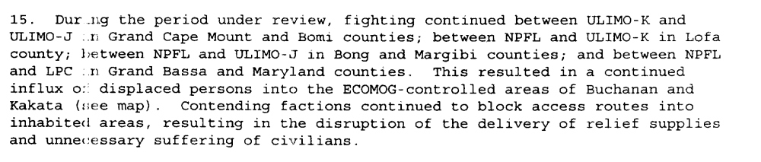
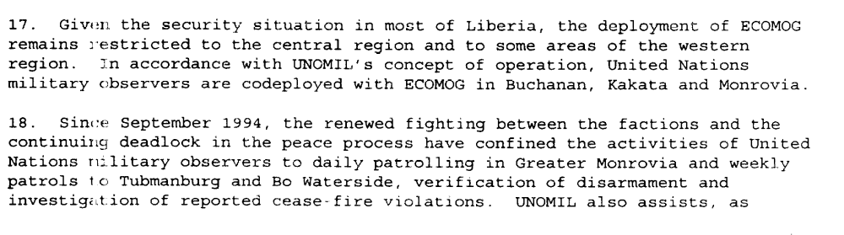
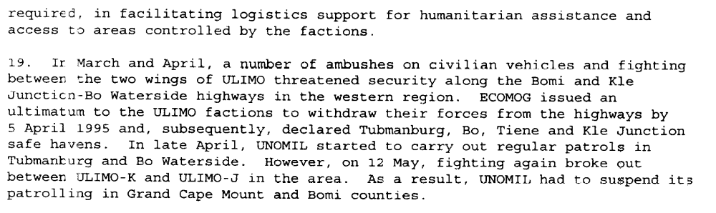
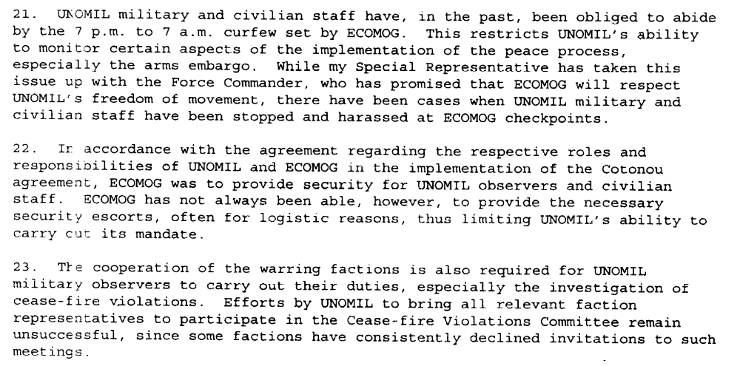
Eleventh Progress Report of the Secretary-General on the United Nations Observer Mission in Liberia, S/1995/473, 10 June 1995

Assessment

Short-term compliance
X No or marginal compliance (1) | Medium low compliance (2) | Medium high compliance (3) | Full or almost full compliance (4)

Considerations underlying the assessment
The demand addressees did not comply with this demand within the six months following the resolution.

Medium-term compliance

Description of the addressee(s)’ conduct

“On 28 December 1995, ULIMO-J combatants attacked ECOMOG troops in the Bomi County town of Tubmanburg, killing sixteen Nigerian peacekeepers, wounding seventy-eight others, and capturing some of ECOMOG’s heavy weapons and other equipment. IN the fighting, ULIMO-J used civilians seeking refuge in a hospital as human shield in a bid to defend Tubmanburg. (…) there were civilian casualties.” (Adebajo 2002: P. 185)
Adebajo, Adekeye. 2002. Liberia’s Civil war: Nigeria, ECOMOG and Regional Security in West Africa. A project for the International Peace Academy. Lynne Rienner Publisher

“Third battle in Monrovia (…) the NPFL fighters called the offensive Operation Pay Yourself, the last great attempt to loot ‘as form of compensation for the combatants who have fought for several years without any benefit from theirleaders’. At least 2000 people were killed in a few days of fighting. Accoding to a UN assessment, the UN and its agencies lost a total of 322 vehicles worth some 4.9 million, while international NGOs lost a further 167 vehicles worth 3,2 million, stolen by the various factions and often sold by the fithers to Ecomog for export. ‘ (Ellis 1999, p. 108).

Ellis, Stephen. 1999. The Mask of Anarchy. New York University Press.

“By the end of 1995, following some initial progress in the implementation of the peace agreements and improvement in the security and humanitarian conditions in the country, the situation in Liberia began to take another turn for the worse. The implementation of the Abuja Agreement was behind schedule. The critical aspects of the Agreement, disarmament and demobilization, did not begin at the time foreseen. There were serious violations of the ceasefire. These violations included intermittent fighting between Alhaji Kromah's forces (ULIMO-K) and Roosevelt Johnson's forces (ULIMO-J). Fighting also occurred between LPC and NPFL and between NPFL and ULIMO-K. There were also delays in deploying ECOMOG personnel and equipment throughout the country. At the end of December 1995, heavy fighting broke out at Tubmanburg as a result of attacks on ECOMOG by ULIMO-J troops. Casualties were suffered by the combatants and by the civilian population.”
(...)
“In this volatile atmosphere, following confrontations between rival groups within ULIMO-J, the transitional government, on 23 March, issued a warrant for the arrest of General Roosevelt Johnson, accusing him of murder. On 6 April, the Rapid Reaction Unit of the national police, backed up by the forces of NPFL and ULIMO-K, attempted to arrest him forcibly. They were attacked by General Johnson's forces, supported by fighters from AFL.”
(...)
“The fighting was accompanied by the complete breakdown of law and order in Monrovia. Fighters from all factions systematically looted the commercial district as well as United Nations offices and warehouses. Houses were broken into, buildings were set on fire and vehicles were commandeered.”
UNOMIL, Liberia, Background
http://www.un.org/Depts/dpko/dpko/co_mission/unomilFT.htm#DECEMBER

“In another gruesome incident, at least twenty-one civilians were killed in Sinje, Gran Cape Mount County, when the village was attacked on 28 September (1996) by ULIMO-K fighters just after it had received food relief. The victims were decapitated, castrated and shot.” ( Adebajo 2002: 206)

Adebajo, Adekeye. 2002. Liberia’s Civil war: Nigeria, ECOMOG and Regional Security in West Africa. A project for the International Peace Academy. Lynne Rienner Publisher

Assessment

Medium-term compliance
X No or marginal compliance (1) | Medium low compliance (2) | Medium high compliance (3) | Full or almost full compliance (4)

Considerations underlying the assessment
Within the two years following the adoption of this demand, the demand addressees did not comply with this demand.

Depth of demand

Assessment

Level of depth of demand
Low depth of demand (1) | X Medium depth of demand (2) | High depth of demand (3)

Considerations underlying the assessment

The demand addressees targeted civilians, peacekeepers and humanitarian organization personnel for military strategic reasons. Compliance with this demand (in isolation with other demands) made it significantly more difficult to win power over other demand addressees.

Level of confidence about coding decisions

Level of confidence about coding decision
Extremely high | High | X Moderate

Comments to IPI (if any)

